**User Experience Engineering**

**SE3050**



**Sketches, Wireframes and Prototypes**

**Group 2021S2_REG_WE_07**

|  |  |
| --- | --- |
| **IT Number** | **Name** |
| IT19209012 | I.D.I Balasuriya |
| IT19210520 | M.R.U.M Senevirathna |
| IT19213590 | G.A.D.K.M Gardiarachchi |
| IT19207100 | A.G.S.P Deshapriya |

Table of Contents

Sketches Wireframes and Prototypes 3

User Testing script 18

# Sketches Wireframes and Prototypes

**Member 1 :**  M.R.U.M.Senewirathna – IT19210520

|  |  |  |
| --- | --- | --- |
| **Sketch** | **Wireframe**  **C:\Users\shanu\AppData\Local\Microsoft\Windows\INetCache\Content.Word\login2.png** | **Prototype** |

**Flow of the sketch:** Login and Forgot Password

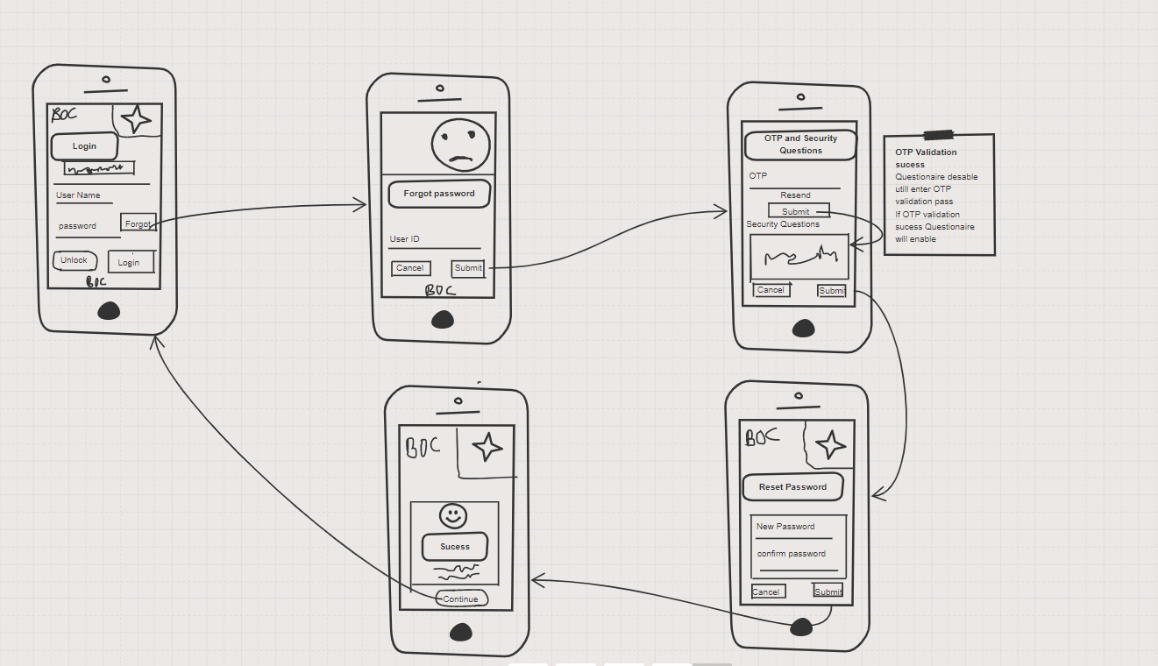

Change Password :

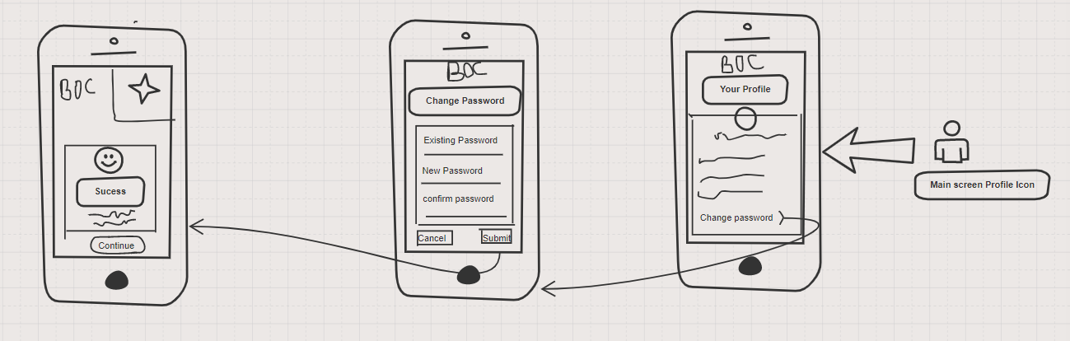

**Member 2 :**  I.D.I. Balasooriya – IT19209012

|  |  |  |
| --- | --- | --- |
| **Sketch** | **Wireframe** | **Prototype** |

**Flow of the sketch:** Dashed board and Forgot Pay bills

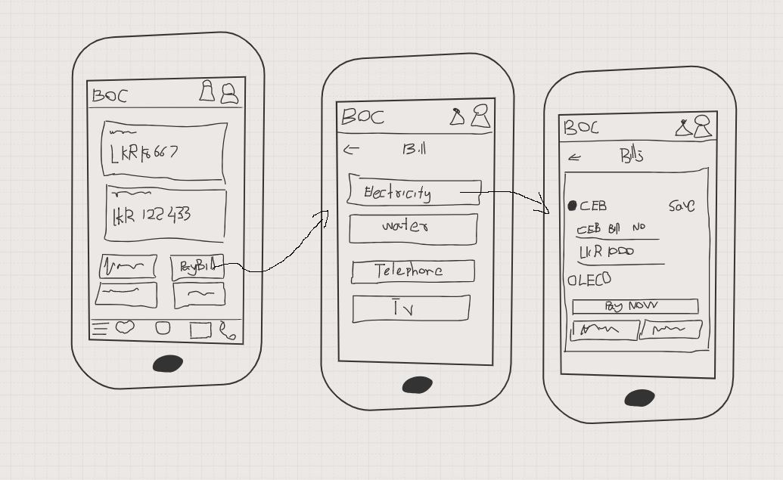

**Member 3 :**  G.A.D.K.M. Gadiarachchi – IT19213590

|  |  |  |
| --- | --- | --- |
| **Sketch**  **C:\Users\shanu\AppData\Local\Microsoft\Windows\INetCache\Content.Word\exchange rates.png** | **Wireframe**  C:\Users\shanu\AppData\Local\Microsoft\Windows\INetCache\Content.Word\confirm.png  C:\Users\shanu\AppData\Local\Microsoft\Windows\INetCache\Content.Word\contact.png  C:\Users\shanu\AppData\Local\Microsoft\Windows\INetCache\Content.Word\exchange.png | **Prototype** |

**Flow of the sketch:** Budget Calculator and Own Account Transfer

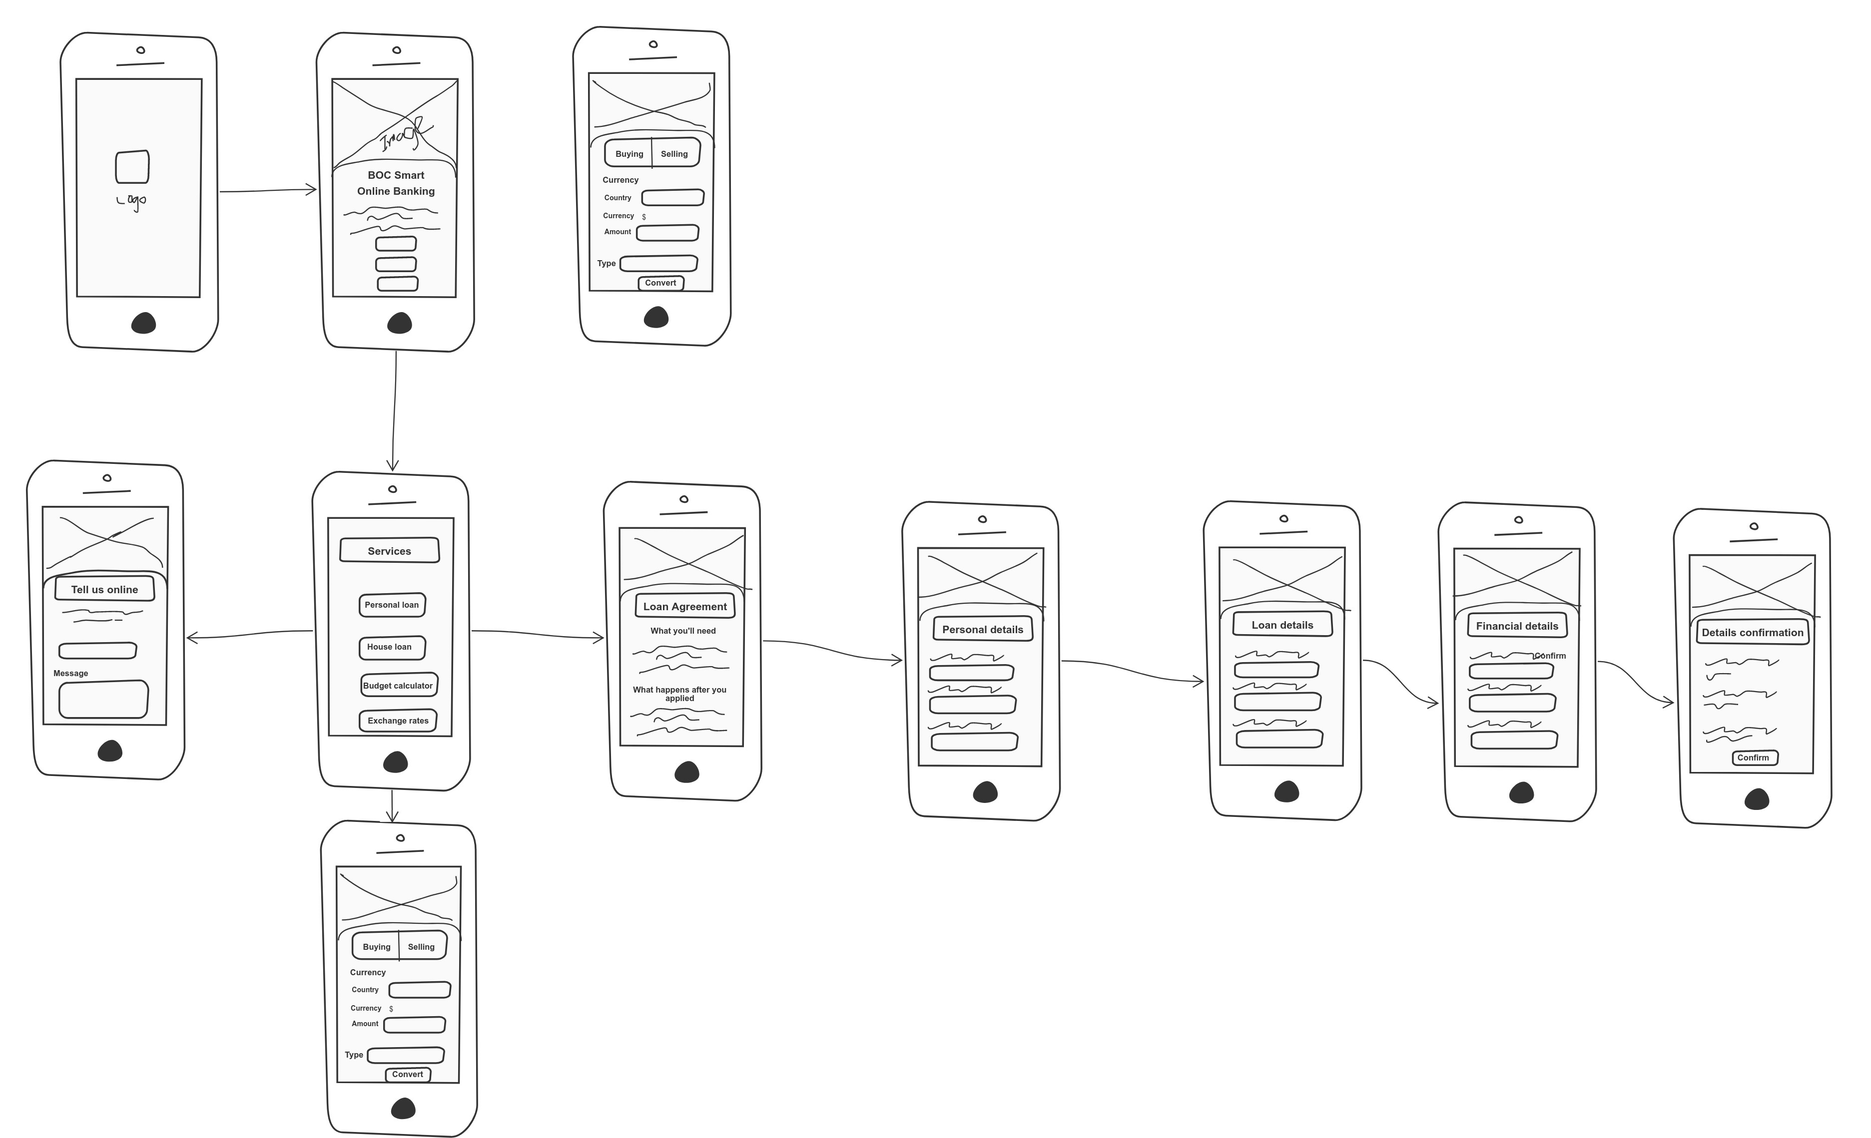

**Member 4 :**  Deshapriya A.G.S.P – IT19207100

|  |  |  |
| --- | --- | --- |
| **Sketch** | **Wireframe** | **Prototype** |

**Flow of the sketch:** Budget Calculator and Own Account Transfer

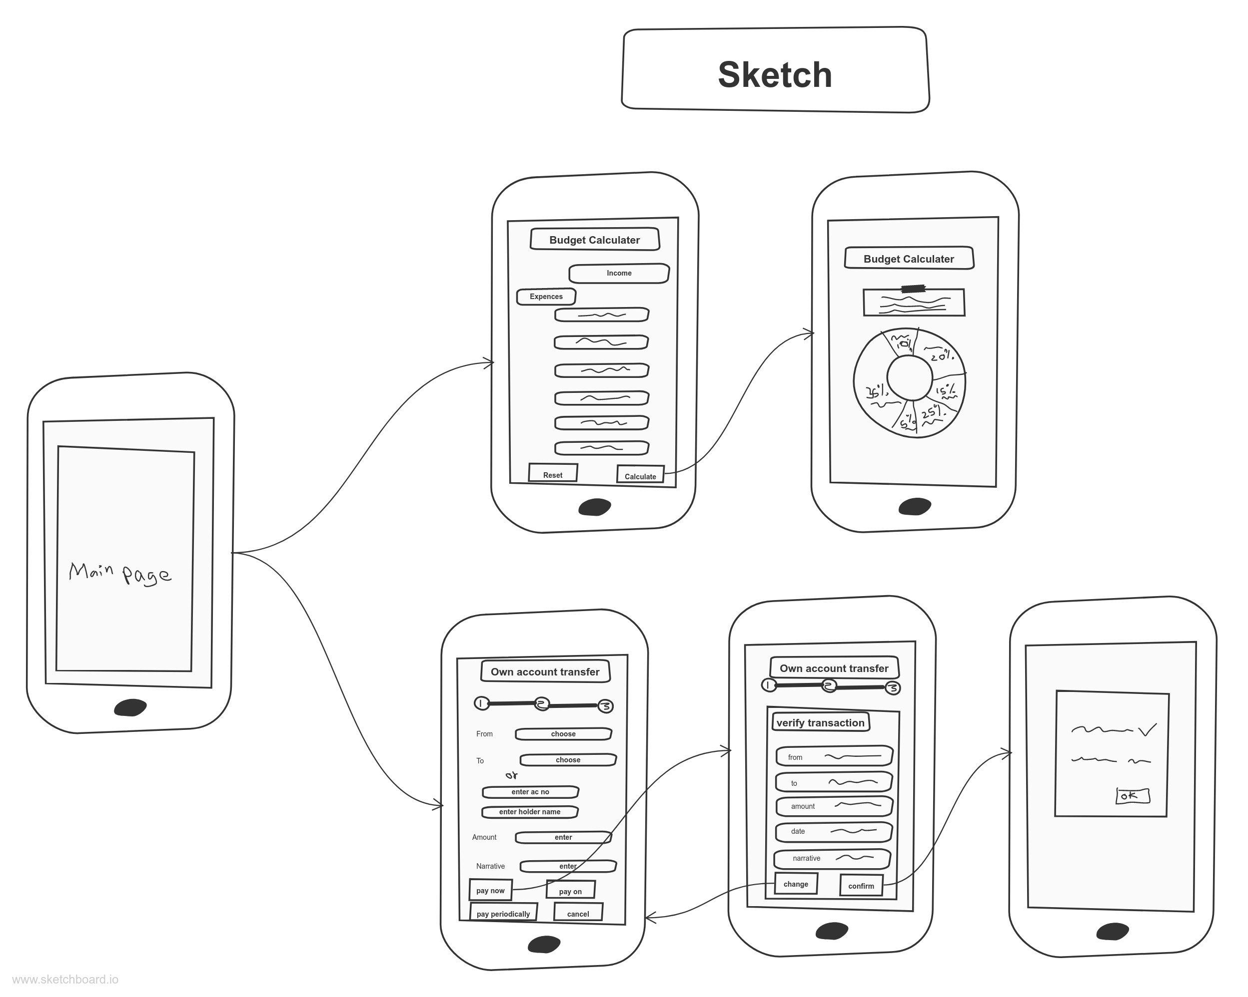

# User Testing script

Interview Video : <https://web.microsoftstream.com/video/c867e0a4-5447-4a88-bec0-64e9ea918b10>

Prototype version 1 : <https://xd.adobe.com/view/7123b806-7fd7-4ccc-bd96-a2ca96d8deb6-2470/>

Prototype version 2 : <https://xd.adobe.com/view/53a505e6-946c-43fa-88bc-580c88935be2-06f6/>

Hi Mr. …………. , Thank you for join us again for another interview. Pervious interview helped us a lot to continue our assignment successfully. Issues you pointed helped us to find fail points of the BOC mobile banking app. Thank you very much for that information.

Before we stared this interview, I will give a brief awareness regarding how this interview going to happen.

Actually, we re-design some of the interface of functionalities of Boc mobile banking app according to the issues you pointed out in the previous interview. From those information we made a primary prototype version. We will show it now to you. What You have do is will give some tasks to perform in that prototype and you have to give your honest opinion about the design. So we will be able to improve it more in user experience wise and user interface wise.

Don’t worry we are not testing your ability to use a mobile app. Only we looking for are lacking of our new design. If you are facing any uncomfortableness, feel free to tell it. So fare Do you have any question ?

Ok, then lets get started

First will let you to use the protype and get used to it?

Are you done?

**Task 1**

Q1. Ok now I think you have used to the prototype functionality?

Q2. Can you perform the forgot password functionality again?

Q3. What do you think about interface beginning of the login screen to rest success screen?

Q4. In the previous interview you said that forgot password control flow is too long. So we merge two screen OTP validation and security question to one page Did you noticed it?

Q5.So what do you thing about that?

**Task 2**

Q1. Can you find the location of change password option?

Q3. In the previous interview you mentioned that location of changing password is too hard to find. Comparing to app you are using what do you think about the prototype version ?

**Task 3**

Q1. Can you move to the dashboard interface? What do you think about this new UI

**Task 4**

Q1. Can you perform a bill payment. What do you think about new bill payment function new bill payment UI

**Task 5**

Q1. Can you move to the budget calculator interface again? What do you think about this budget calculator

**Task 6**

Can you move to the Own account transfer interface again? Did you remember you told us money transfer page is too time consuming because there is no option to type other party account details by itself. So by considering that issue we redesigned it.What do you think about this Own account Transfer?

**Task 7**

Q1- What you think about the home screen by comparing previous app?

**Task 8**

Q2 – Exchange rate section

**Task 9**

Q3 – Service menu

**Task 10**

Q4 – Loan agreement

Thank you very much for allocating time for our interview with your busy schedule. We were able to clarify mistakes and inconveniences of our design. Thank you again, have a good day Bye.